Presented by: Herd immunity

Fontys university for Applied sciences

Rachelsmolen 1, 5612 MA Eindhoven



DESIGN DOCUMENT

Herd Immunity simulation

Version 1

June 3, 2018

Table of Contents

Formal Client 2

Members 2

Simulation core class diagram: 3

Simulation core class descriptions 3

Scene 3

Person 4

Disease 4

PopulationProperties 4

DiseaseProperties 5

VaccineProperties 5

Infection 5

Utility 6

Statistics 6

Constants 7

Simulation Sequence Diagram 8

# Formal Client



**Mr. Johnson**

Email: c.kuah@fontys.nl

Phone number: ​+31 885074156

# Members

| Name | STN | PCN | Mail |
| --- | --- | --- | --- |
| Alalao Ali | 3107493 | 369697 | a.alalao@student.fontys.nl |
| Bolbol Obaida | 2956160 | 356432 | o.bolbol@student.fontys.nl |
| Nikov Kaloyan | 2961075 | 356847 | k.nikov@student.fontys.nl |
| Sikorska Iwona | 3197980 | 377191 | i.sikorska@student.fontys.nl |

# Simulation core class diagram:

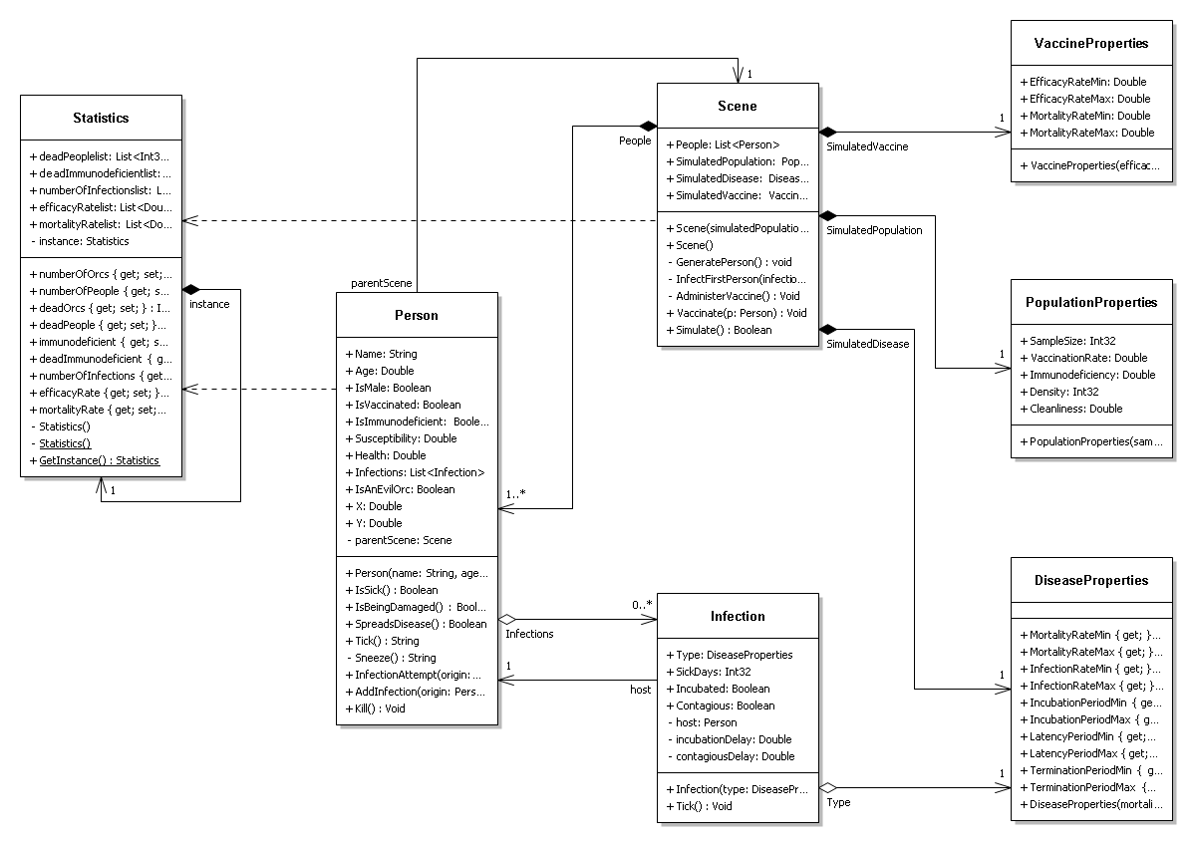

# Simulation class descriptions

Core elements are underlined.

## Scene

Scene is the container and manager for all of the simulation actors.

**Fields:**

* People: List of people within the simulation scene
* SimulatedPopulation: Properties of simulated population sample
* SimulatedDisease: Properties of simulated disease
* SimulatedVaccine: Properties of vaccine that protects from simulated disease
* ReportFilename: Stores the filename of the report written at end of simulations
* InfectionLinks: Stores the infection chain displayed during rendered simulation
* numberOfDays: The amount of days the simulation simulates
* passedDays: The amount of passed days inside the simulation
* GFXEnabled: Used to distinguish between render and non – render mode

**Methods:**

* Scene: Constructor
* GeneratePerson: Generates a person according to population properties
* GenerateAppearance
* Simulate: Advances this scene’s actors a day further
* InfectFirstPerson: Infects the first person to start the disease
* AdministerVaccine: Vaccinates people before start of simulation
* Vaccinate: Vaccinates single person
* GenerateLabel: Generates the label for a person
* Simulate: Runs the simulation
* GetPeopleInRange: Returns the people in specified the range
* GetNewCoordinates: Gets random coordinates for person
* InfoString: Info string to show during simulation

## Person

Person is a simulation actor that represents one of people.

**Fields:**

* Name: Person’s name
* Age: Person’s age
* IsMale: Whether the person is of male or female gender
* Susceptibility: Person’s susceptibility to diseases
* Health: Health state
* Infections: Infections that affect this person
* X: Horizontal position
* Y: Vertical position
* IsAnEvilOrc: Determines whether this person accepts vaccinations
* Sprite: Person’s graphical representation
* IsVaccinated: Whether this person is vaccinated or not
* IsImmunodeficient: Whether this person is considered immunodeficient
* parentScene: The scene to which the person is attached

**Methods:**

* Person: Constructor
* Draw: Draws this person’s graphical representation
* Tick: Processes this actor (a day forward)
* IsSick: returns true if person is sick
* IsBeingDamaged: returns true if person is being damaged
* SpreadsDisease: returns true if person is infectious
* Sneeze: simulates a person spreading disease
* InfectionAttempt: simulates infection attempt over a person
* AddInfection: adds infection to a person
* Kill: kills the person
* onDeath: this executes on person’s death
* InfoString: info string about the person to show during rendered visualization

## INFECTION

Infection is a simulation actor that represents disease on a specific host (person)

**Fields:**

* Type: Properties of this disease
* SickDays: Infection day count
* Incubated: Whether this infection is incubated and affects its host
* Contagious: Whether this infection is currently contagious
* host: Person host that this infection is assigned to
* incubationDelay: Delay until this infection becomes incubated
* contagiousDelay: Delay until this infection becomes contagious

**Methods:**

* Infection: Constructor
* Tick: Simulates the infection a day forward

## DiseaseProperties

Properties of simulated disease.

**Fields:**

* MortalityRateMin: Minimal chance that infected person will expire
* **MortalityRateMax: M**aximal chance that the person will expire
* **InfectionRateMin: Minimal chance that exposed person will become infected**
* **InfectionRateMax: Maximal chance that exposed person will become infected**
* IncubationPeriodMin: Minimal day amount after which the disease starts damaging their host
* IncubationPeriodMax: Maximal day amount after which the disease starts damaging their host
* LatencyPeriodMin: Minimal day amount after which disease becomes infectious
* LatencyPeriodMax: Maximal day amount after which disease becomes infectious
* TerminationPeriodMin Minimal amounts of days after infection after which the host expires
* TerminationPeriodMax: Maximal amounts of days after infection after which the host expires

**Methods:**

* PopulationProperties: Constructor

## PopulationProperties

Properties of simulated population.

**Fields:**

* SampleSize: Amount of individuals in this simulated sample
* VaccinationRate: Rate of vaccination
* Immunodeficiency: Rate of immunodeficiency
* Density: Density of the environment where the population is situated
* Cleanliness: Cleanliness of the environment where the population is situated.

**Methods:**

* PopulationProperties: Constructor

## VaccineProperties

Properties of simulated vaccine.

**Fields:**

* EfficacyRateMin: Minimal chance that vaccinated person will develop immunity
* EfficacyRateMax: Maximal chance that vaccinated person will develop immunity
* MortalityRateMin: Minimal chance that vaccinated person will expire
* MortalityRateMax: Maximal chance that vaccinated person will expire

**Methods:**

* VaccinationProperties: Constructor

## Utility

Class containing utility functions used in multiple classes.

**Fields:**

* randomNumberGenerator: Used for random generation in the class

**Methods:**

* GetHealthColor: Returns the health color based on value
* ToNumericControlValue: Converts from string to numeric
* FromNumericControlValue: Converts from numeric to string
* Random: Returns random number between 2 values
* Roll: Rolls between 1 and 100
* GetDistance: Returns the distance between points
* Repeat: Repeats a certain action
* GetSusceptibilityWeightedValue: Returns the weighted value of the susceptibility
* GetSpriteRect: Returns the sprite rectangle position
* AddToSprite: Adds texture to a sprite
* RollWithSusceptibility: Random roll taking susceptibility into account
* GetStep: Used for stepping in multiple simulations

## STATISTICS

Class for keeping track of statistics during simulations.

**Fields:**

* deadPeoplelist: Stores the dead people from previous simulations
* deadImmunodeficientlist: Stores the dead immunodeficient people from previous simulations.
* numberOfInfectionslist: Stores the number of infections from previous simulations
* efficacyRatelist: Stores the efficacy rate from previous simulations
* mortalityRatelist: Stores the mortality rate from previous simulations
* instance: Stores the instance of the object as this is a singleton class
* timestamp: Used for creating the filename so it’s easy to keep track when it happened.
* statistics properties: Various statistics properties that are being kept track of

**Methods:**

* Statistics: Constructor
* GetInstance: Returns the instance of the singleton object
* writeStatisticsReport: Writes a text file, which contains a report of the simulation

## Constants

Static Class for keeping the constants during simulations.

# Simulation Sequence Diagram

